L&T Bid Response

To

TENDER NO. GTC/995/2020
SMART MONITORING OF PRIMARY EQUIPMENTS BY INTEGRATION OF TMS & PDM SYSTEM BETWEEN PRIMARY SUBSTAIONS AND NCC

Bidder Technical Check List 5.7

Technical Offer

Submitted on: Sept 24th, 2020

Table of Contents

Contents
1. Technical - Executive Summary 4
1.1 Introduction 4
1.2 Technical Advantages 5
2. Solution Architecture 6
2.1 Integration Architecture 6
2.2 Functional Architecture 9
3. Functional Design 12
3.1 Overview 12
3.2 Holistic Approach for Asset Health Management 12
3.3 Handling of Non-available Parameters 13
4. Functional Description 15
4.1 Data Store & Algorithm (DSA) - Diagnostic Tools 15
4.2 Data Store & Algorithm (DSA) - Asset Health Index (AHI) 18
4.3 Data Store & Algorithms (DSA) - Archival 21
4.4 Application Function Engine – Alarms & Notification 21
4.5 Application Function Engine – Reporting 22
4.6 End User Interface - Dashboards 23
4.7 End User Interface – Reports 25
4.8 End User Interface – Alerts & Notifications 26
5. System Features & Services 28
5.1 Cybersecurity 28
5.1.1 End Point Security 29
5.1.2 Application Security 30
5.2 Identity Access Management 31
5.3 Network Security 32
5.4 OT Security Monitoring 32
5.5 Change and Patch Management 33
5.5.1 Create/Log a Request for change (RFC) 33
5.5.2 Review RFC 34
5.5.3 Evaluate RFC 34
5.5.4 Approve and Authorize the Change 34
5.5.5 RFC - Implement the Change 34
6. Training 35
6.1 User Interviews 35
6.2 Training with full compliance 35
6.3 Theoretical Training 35
6.4 Practical Training 36
7. Product Warranty Support 39
7.1 Overview 39

Technical - Executive Summary

Introduction
The proposed L&T’s Smart Condition Monitoring System (referred as SCMS henceforth in this document) will integrate all TMS (Transformer Monitoring Systems) together with DGAs (Dissolve Gas Analyzers) and PDM (Partial Discharge Management) systems located within Kahramaa’s primary substations of Electricity Transmission Network.
The proposed technical solution consists of following components:
- L&T’s Substation Data Gateway (SDG) - A class of Digital Field Integration Platform (DFIP) will be deployed at each substation for integrating Kahramaa’s existing online condition monitoring systems consisting of TMSs, DGAs and PDMs using IEC61850 or Modbus protocol (as applicable).
- L&T’s Smart Condition Monitoring System (SCMS) - A class of Digital Control Integration Platform (DCIP) will be deployed with all the application server components at KM1 building and Human Machine Interface (HMI) components at KM5 building.
Figure 1 provides the schematic of the L&T’s technical solution components for deployment at Kahramaa.
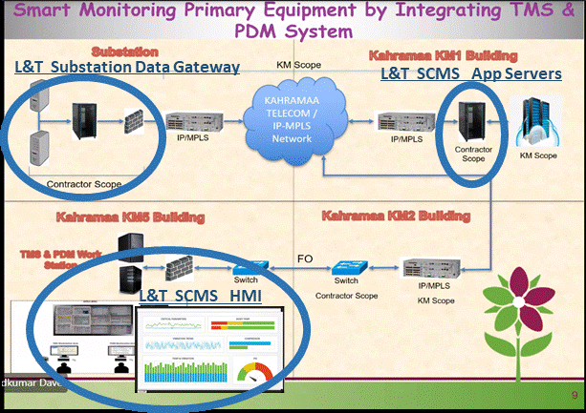
Figure 1: L&T’s Technical Solution – SDG at Substation & SCMS at KM1 & KM5
The proposed integrated solution will tie all the asset condition information together with required actions to deliver the effective and informed decision support system to prevent failures in the primary equipment Transformer, Reactor, Gas Insulated Switchgears) and suggest required maintenance schedules for specific ‘at-risk’ assets, based on industry standard methods. The SCMS solution will provide access to data, information and advisory recommendation through the operator consoles in the Kahramaa’s KM-5 building.

Technical Advantages
- While meeting Kahramaa’s needs today, the proposed L&T’s solution represents a future proof integrated solution, built with field proven components, powered by world leaders in the ICT domain (INTEL, TABLEU) and T&D Asset Management domain ( OSI Soft, DOBLE)
- L&T’s SCMS is built upon various industry standard best practices for Asset Monitoring and management such as,
  - Failure Mode, Effects & Criticality Analysis (FMECA)
  - Reliability Centered Maintenance (RCM)
  - Condition Based Asset Monitoring
  - Root Cause Analysis (RCA) via Complex Event Processing (CEP)
The solution enables quick and complete Reliability Centered Maintenance (RCM) studies and recommendations based on asset criticality. Such studies, together with complex event processing (CEP) and near real-time analysis, provides Kahramaa an effective Decision Support System (DSS).
- The SCMS facilitates data management and presents asset data with state-of-the-art ease of use and navigation for the operators.
The SCMS provides real-time data and analyses asset behavior, down to component level if necessary, to arrive at the optimum asset performance and maintenance strategy based automated data and risk analysis. This data is presented to the operator via intuitive and intelligent dashboard and reporting functions.
- Built with modular and scalable architecture powered by use of standard data models supporting asset hierarchies through various methods.
- The SCMS is also capable to integrate with most Enterprise Work and Asset Management System solutions for future roadmap via standard Application program interfaces (APIs).
- L&T’s solution ensures efficient and effective condition-based monitoring operation with optimized total cost of ownership through following features:
  - Business intelligence decision support system delivering value via intuitive and user configurable dashboards, reports and analytics to define and manage asset strategies with a risk-based approach for improved planning and efficiency
  - Reduced time and expense for new systems integration and implementation
  - Built-in cyber security to ensure data integrity for data-at-rest as well as data-in-transit
  - Fully automated complex event processing to rank assets by severity based on user configurable key performance indicators (KPIs) as well as deliver predictive asset maintenance plans
  - Dedicated alarm and notifications engine with decluttering and configurable prioritization features for effective asset management
  - Integration (via APIs) with many Work and Asset Management System to create and track maintenance and repair plans
  - User configurable analytics engine providing pre-built industry standard algorithms for asset condition assessment
  - Data archival and retrieval module to seamlessly analyze data irrespective of the time horizon (few minutes to several years)
  - Rich web-based Application user interfaces accessible via standard internet browsers
  - Remote monitoring and management of TMS/PDM systems via secure connection from central console
  - NERC-CIP compliant user management and system security
  - Role-based user access controls
  - Rule based analytics to accurately predict equipment issues before they occur
  - Continuous, real-time analysis and visibility for automated risk mitigation while balancing associated costs, risks, and benefits
  - In-built analytics
    - to reduce unplanned asset downtime
    - to predict problems resulting in condition-based asset maintenance plans as opposed to run-to-failure maintenance plan thus increasing reliability and reducing O&M costs
    - to predict asset-related incidents thus protecting safety of the employees

Solution Architecture

Integration Architecture
The following diagram depicts the solution integration & deployment architecture for the SCMS solution.

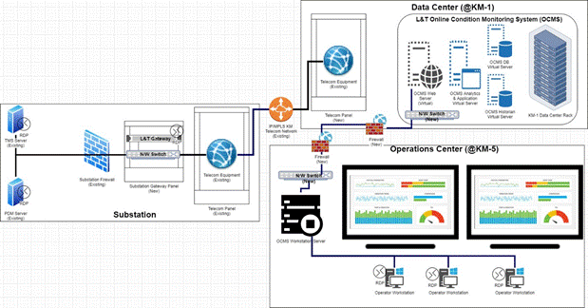

Figure 2: L&T’s Technical Solution – System Integration Architecture

Physical Components
The solution has following physical components:
Solution Component | Location | Minimum Specifications
SCMS Web Server (Virtual) | KM-1 Data Center | 2 vCPU, 16 GB RAM, 500 GB HDD, Windows 2019 Server
SCMS Analytics & Application Server (Virtual) | KM-1 Data Center | 6 vCPU, 32 GB RAM, 1 TB HDD, Windows 2019 Server
SCMS Operational Database Server (Virtual) | KM-1 Data Center | 4 vCPU, 32 GB RAM, 1 TB HDD, Windows 2019 Server
SCMS Historian Server (Virtual) | KM-1 Data Center | 4 vCPU, 32 GB RAM, 5 TB HDD, Windows 2019 Server, OSI Soft PI Historian
SCMS HMI Workstations | KM-5 Operations Center | Intel® Core™ i7-10700T (8 Cores/16MB/16T/2.0GHz to 4.5GHz/35W), Windows 10 Pro 64bit English, French, Spanish, 16GB, 1x16GB, DDR4 non-ECC Memory, M.2 256GB PCIe NVMe Class 40 Solid State Drive
Network Firewall | KM-1 Data Center | CISCO Firewall FirePower 2110
Network Firewall | KM5- Operations Center | CISCO Firewall FirePower 2110
Wall Monitors | KM5- Operations Center | Ultra-HD Interactive Display
Network Switch | KM2 and KM5 | Cisco Switch (Catalyst WS3650-24TS) equipped with 4 SFP/1G
L&T Substation Data Gateway (SDG) | Each Substation | Intel® Core™ i3, Windows 64bit English, French, Spanish, 8GB, 1x8GB, DDR4 non-ECC Memory, M.2 256GB PCIe NVMe Class 40 Solid State Drive
Firewall | New substations where new TMS to be installed (or substations where IMS needs to be separated) | Cisco Industrial Security Appliance 3000 (ISA)
Network Switch | Each Substation | Moxa PT-7728 Series
GPS Clock + Antenna | KM2 | LANTIME M300

Data, Application and System Services
Web Application Services: All data acquired and processed by the SCMS can be accessed by users via rich web based intuitive framework, and intelligent user interfaces. These user interfaces are exposed via the web application server using HTTPS connection.
Business Data and Application Services: The Data and Application services are built using micro-services architecture which is used by all solution components in SCMS to interact with each other. The Data and Application Services ensure data quality, integrity and security of the information exchanged between various components and subcomponents of the solution.
System Services – Authentication, Authorization, Auditing & Identity Management (AAAIM): The AAAIM services secure SCMS system and subsystems against unauthorized access. These services ensure data integrity and authenticity of the SCMS solution. Authentication acts providing proof of authenticity for stored data and verifying proof of authenticity for received. Authorization acts providing privileges to those clients that present specific credentials. Auditing saves all user and network actions in audit and error logs to facilitate reporting and assurance of the data integrity, application and system security.

Functional Architecture

The following diagram depicts the functional architecture for the SCMS solution.
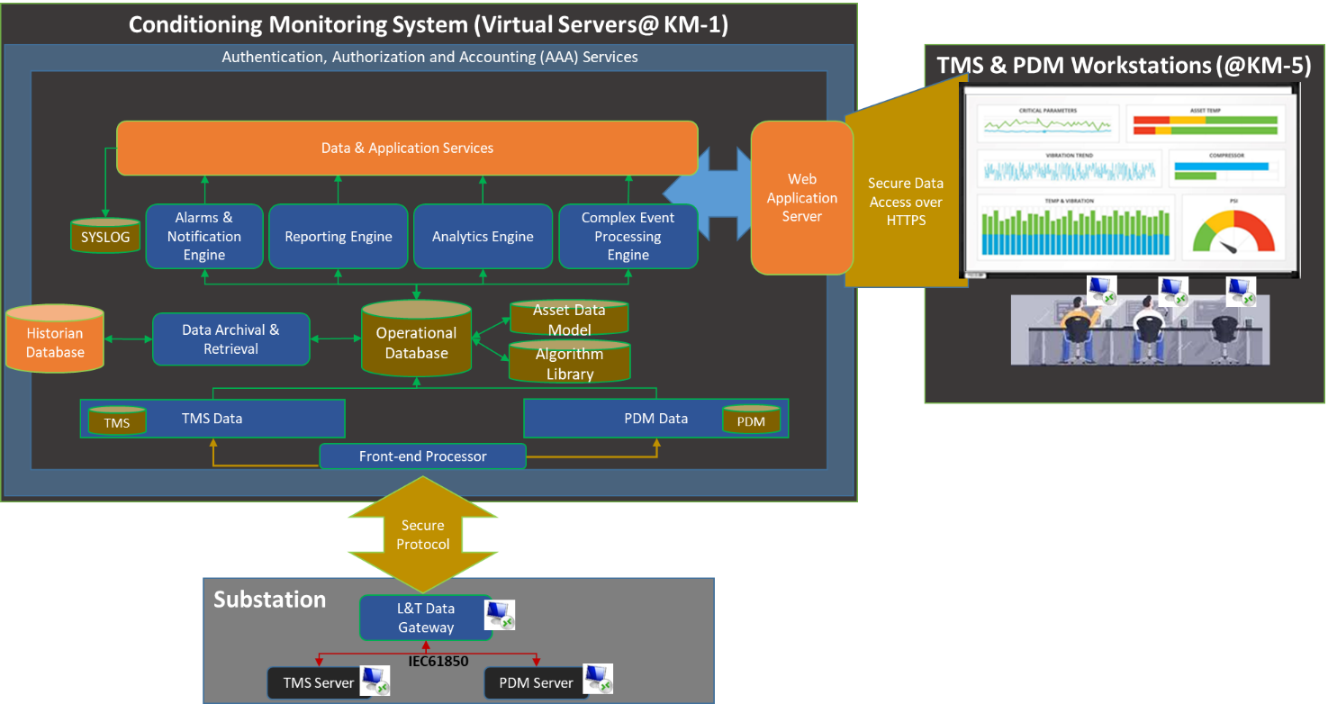
Figure 3: L&T’s Technical Solution – Functional Architecture

The SCMS Solution has a multi-layer scalable distributed architecture as described below:
(1) Substation Data Gateway (SDG): The SDG is a software defined gateway that collects data from substation automation components as well as primary equipment via industry standard protocols such as DNP3 TCP, IEC61850, Modbus TCP, OPC UA etc. For the Kahramaa SCMS project the SDG will act as a node on the SCS (Substation Communications TCP/IP network) to collect data in near real-time using IEC61850 and/or Modbus TCP from existing TMS and PDM servers. The SDG will correlate the acquired data with the asset data model, formats it and send the data on period (configurable frequency) basis from substations to central SCMS (SCMS) system using Kahramaa’s existing IP/MPLS network.
(2) Front End Processor (FEP): The FEP is deployed in the control data center on physical or virtual machine and collects the data from field devices/substations. For the Kahramaa project the FEP will poll the data from each SDG via secure channel using MQTT protocol over the IP/MPLS network. The data is stored in segregated schemas in Operational Database for TMS and PDM data.
(3) Data Stores & Algorithms (DSA): This layer consists of Operational Database, Asset Data Model, Algorithm Library and Historian Database. The Operational Database keeps all data collected from the substations from Layer 2 and the correlated and calculated analytics results & reports. The Operational Database is sized to keep the operational data on 5 years rolling window basis. The operational data collected from the substation devices is also in the historian which is implemented using OSI Soft PI historian server. The historian database will be able to store the data for up to 35 years. The Asset Data Model is used to keep the physical, operational and functional attributes of the assets that are being monitored by SCMS, and servs as Master Data File record for all assets under monitoring. The Algorithm Library database has the industry standard algorithm related data saved as library that in turn is used to correlate Operational Data, Asset Data Model and Historic data to produce meaningful and actionable analytics results and report.
(4) Application Function Engine (AFE): The Application Function Engine has four major functions as listed below. These components are described in the subsequent sections of this document.
- Alarms & Notifications Engine
- Reporting Engine
- Analytics Engine
- Complex Event Processing Engine
(5) End User Interface (EUI): The End User Interface will support all types of user through Human Machine Interface (HMI) at KM5 building. Key subcomponents of the EUI include:
- Operator Workflow & Controls
- Alters & Notifications
- Dashboards
- Reports

Functional Design

Overview

Our proposed SCMS functions are designed following overarching principles of ISO 5500 consisting of its framework of seven key activities:
- Policy development
- Strategy development
- Asset management planning
- Implement asset management plans
- Asset management capability development
- Risk management and performance improvement
- Asset knowledge management

As required by the RFP, our SCMS functional design is focused on the 4th and 7th activities as follows:
- The fourth activity, Implement asset management plans, includes maintenance and optimization of assets.
- The sixth activity, Risk management and performance improvement, includes performance monitoring.

In alignment with above 7 key activities, optimized maintenance strategies should align with a Reliability Centered Maintenance (RCM) philosophy. We have embraced an RCM III viewpoint which adds risk consideration to the traditional RCM philosophy. The result is a recognition that the ultimate goal of our offering is to preserve critical Transformer and Reactor functions as well as those critical functions performed by other substation assets.

To meet this goal, L&T clearly understands that Kahramaa has chosen a maintenance strategy that leverages condition monitoring techniques respect economic and technical effectiveness, while eloquently dovetailing with traditional periodic condition assessment and preventive maintenance (renewal) activities.

For the Kahramaa Central Monitoring system to be an effective and optimal decision-making tool, our functional design will ensure to manage and leverage both the TMS and PDS data streams while at the same time allowing for periodic asset condition and maintenance information from other discrete sources where possible.

Holistic Approach for Asset Health Management

Our development approach compliments a holistic approach to Asset Risk Management by employing a comprehensive methodology and product infrastructure that brings all elements of asset health and business impact together. Our software tools will help Kahramaa target, analyze, predict, summarize and report the state of their transformer, reactor and GIS asset base.
Our foundation is RCM and the mature and proven discipline of Failure Mode & Effect Analysis (FMEA); a step-by-step approach for identifying all likely ways a design, a manufacturing or assembly process, a product or a service may fail to perform mission critical functions. An FMEA is often an early step in a system reliability study. FMEA involves analyzing (breaking into pieces) as many components, assemblies, and subsystems as needed to fully identify their interactions, dependencies, failure modes, their causes and the full range of impacts each failure has on the asset and the electrical system. For each component, the failure modes and their resulting failure effects are recorded. “Failure modes” describe the general ways, or modes, in which something might fail or age.

Using FMEA on Transformers, Reactors and GIS, the likely causes of incipient failure are corelated with diagnostic and sensor information. This approach allows for the creation of an Asset Health Index (AHI) that more comprehensively reflects the overall condition and health of the asset. The resulting AHI is based on the current condition and most likely causes of asset failure, not limited to high-level/generalized analysis of like-collected data from disparate sources.

By using FMEA to create the AHI as well as determining the associated risks, it is possible to analyze the overall monetary impact a failure will have on the electric system considering its current condition and possible future condition. The ranking of assets by financial exposure allows for more effective maintenance, OPEX and CAPEX planning; both short and longer term, prioritized implementation of online monitoring and strategic integration of additional operational data.

Going one step beyond FMEA, our proposed solution will perform a FMECA (Failure Mode, Effect and Criticality Analysis) execution. FMECA considers the unique operational aspects of an asset; recognizing that not all assets are equal, nor do they necessarily perform identical functions. The result is detailed understanding of:
• Failure likelihood
• Failure effects
• Asset function criticality

This understanding will provide the key ingredients of calculating both actual and relative risk. Actual risk is monetized, and relative risk is normalized using a score from 0 to 100.

Handling of Non-available Parameters

This section responds to the following RFP requirement:
“Non availability of monitored parameter shall be monitored through a factor of completeness modelling”
There are two general reasons for a parameter to be not available:
- Partial or full failure of the monitor
Kahramaa has installed numerous Serveron and Transfix On-line DGA monitors. Historically, the Transfix models have been of lower reliability and the Serveron units have ‘consumables’ that need to be replaced periodically as well as some component failures. This has caused utilities to:
- Initiate unplanned diagnosis and repair of the monitor. This work is routinely performed by a third party and can require:
  - A diagnostic trip to the substation
  - Ordering of replacement parts
  - A repair trip to the substation
Or
  - A removal and replacement trip to the substation
  - Reconfiguration of the replacement unit
  - Return of the failed unit to the OEM

Serveron/Qualitrol units require periodic replacement of the carrier and calibration gases about every 3 years. If there are leaks or if sampling frequency is high, the time will be less. Not difficult tasks but there is opportunity for human error.
- Monitor does not include the needed parameter
The Serveron/Qualitrol DGA units are 9 gas monitors, they provide all the needed gas parameters. The Transfix models can be 3, 5 or 9 gas monitors. For the 3 and 5 gas monitors, periodic laboratory DGA is needed to augment the on-line tests.
L&T ‘s solution component – namely INSIDEVIEW has the capabilities to import Laboratory Test results to augment those from an on-line monitor.
Figure 4: L&T’s Handling of non-available parameters – Capabilities to import Lab Test Results

Functional Description

Data Store & Algorithm (DSA) - Diagnostic Tools

This functional component addressed the following RFP requirement:
“Apart from Asset health the software shall have various diagnostic tools (Duval triangle, Duval Pentagon, IEC methods, IEEE Conditions, Cigré risk assessments, recommendations, major utilities benchmarks) both at child & parent level to have the realistic in diagnosis.”
Our proposed oil DGA diagnostic tool includes:
- Asset nameplate information
- DGA Monitor data (Continuous-near real time)
- Laboratory test data (periodic)
- Assessments
- Asset performance indicators
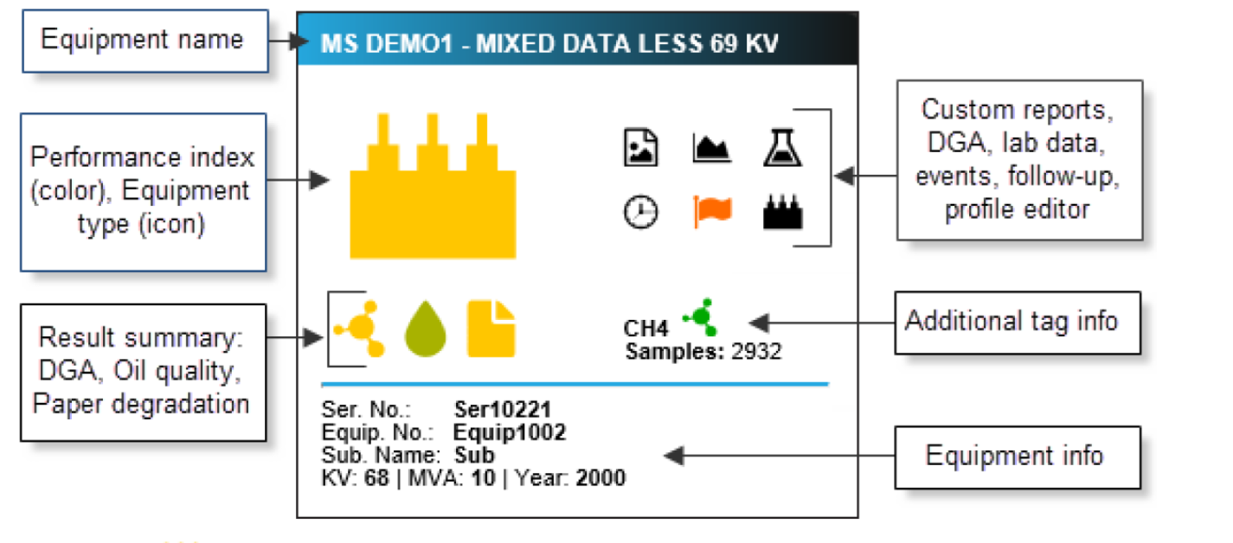
Figure 5: L&T’s Solution Component for DGA diagnostic tool
Specific Analytic Techniques on the DGA data (both on-line monitoring and laboratory) include:
- Duval Triangle (Part of Doble INSIDEVIEW)
The Duval Triangle is a frequently used tool developed to interpret DGA results in power transformers. It is a graphical – triangular mode that allows one to follow results easily, using the visual mapping of the triangular indications. The Duval Triangle looks at 3 gases: c2h2, c2h4, and ch4. These gases are summed, percentage of each is calculated. Calculated values are plotted on the triangular coordinates. Zones defined on the triangle include: D1, D2, DT, T1, T2, T3. Each zone is defined in terms of gas profiles/percentages generated and are indicative of level and type of thermal and activity.
- D1: low energy electrical discharges,
- D2: high energy electrical discharges,
- T3: high temperature phenomena (thermal faults >700 ◦C),
- T2: high temperature phenomena (thermal faults of 300 to 700 ◦C), and
- T1: overheating (thermal faults <300 ◦C)

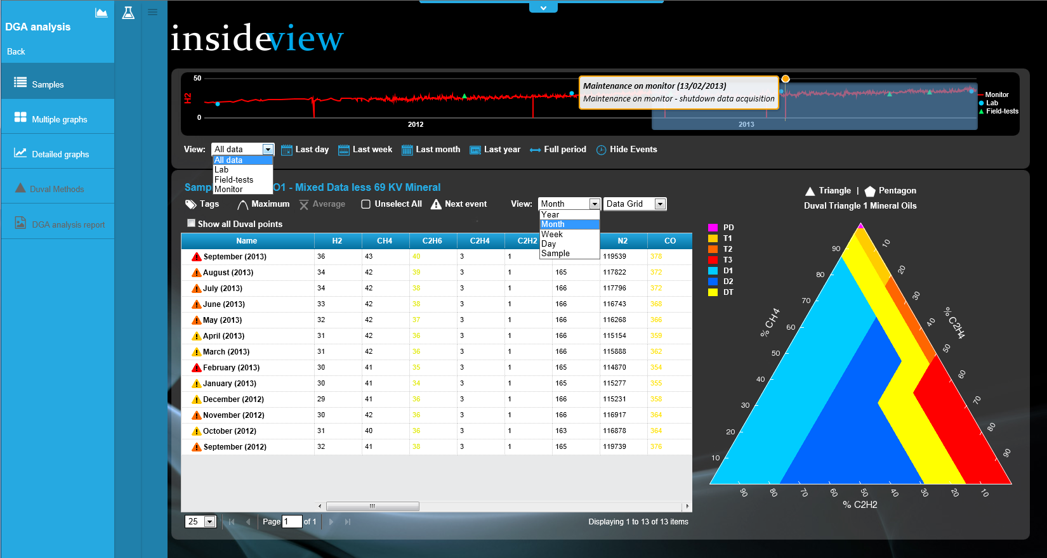
Figure 6: L&T’s Solution Component – Data Analysis with Duval Triangle
- Duval Pentagon
The Duval Pentagon is a graphical tool, similar to the Duval Triangle that allows one to follow results easily, using visual mapping. The Duval Pentagon looks at 5 gases: c2h2 (acetylene), c2h4 (ethylene), ch4 (methane), H2 (Hydrogen) and C2H6 (ethane). These gases are summed, percentage of each is calculated. Calculated values are plotted on the triangular coordinates. Zones defined on the pentagon include: PD, D1, D2, DT, T1, T2, T3, and S. Each zone is defined in terms of gas profiles/percentages generated and are indicative of level and type of thermal and fault activity.
- PD: corona partial discharges,
- D1: low energy electrical discharges,
- D2: high energy electrical discharges,
- T3: high temperature phenomena (thermal faults >700 ◦C),
- T2: high temperature phenomena (thermal faults of 300 to 700 ◦C), and
- T1: overheating (thermal faults <300 ◦C)
- S: Stray gasses

- Total Dissolved Combustible Gas (TDGC)
TDGC is calculated for every sample point, based on the latest DGA data for the following gases: acetylene (C2H2), ethylene (C2H4), ethane (C2H6), methane (CH4), carbon monoxide (CO), and hydrogen (H2). When present, the gas concentrations in PPM are summed and returned as TDGC. TDGC is a rough expression of how much high thermal activity is occurring within the insulating medium; higher values indicate worsening conditions. This value is displayed as The Total Dissolved Combustible Gas and is used for analytics involving thermal activity in oil.
TDCG = C2H2 + C2H4 + C2H6 + CH4 + CO + H2
- Roger Ratio
The Rogers analytics use a set of gas ratios to detect abnormal conditions in oil. Three ratio values are calculated: c2h2/c2h4 (R1); ch4/h2 (R2); c2h4/c2h6 (R5)
- IEC
The IEC 60599 evaluation uses a modified version of the Rogers Ratio methodology to identify faults, as identified in IEC 60599-2007.
Three ratio values are calculated: c2h2/c2h4 (R1); ch4/h2 (R2); c2h4/c2h6 (R3). Ratios are calculated only if one or more of the following thresholds are met:
Gas thresholds: c2h2>20; c2h4>280; ch4>130; c2h6>20; ch4>130; h2>150
- Cigré
This is not a specific analytic method but expands on IEC 60599 with improvements, such as the formation of gases from stray gassing oils, partial discharges and gas formation from paper insulation.
- IEEE
The IEEE evaluation uses the tables in the IEEE C57.104-2008 standard to evaluate relative gas concentrations. C57.104 defines a 4-tier (Conditions 1 through 4) system for classifying gas data.:
- Arcing based on C2H2 (Acetylene)
- Partial Discharge based on H2 (Hydrogen)
- Thermal Oil based on CH4 (Methane)
- Thermal Paper (based on CO)
In addition to DGA, oil quality analytics are also included:
- IFT - looks at the interfacial tension of an oil sample, calculated in dynes/cm.
- Neutralization Number - looks at the relative acidity of an oil sample, calculated in milligrams of potassium hydroxide (KOH) required to neutralize a gram sample of material. Higher values indicate more acidic material, which can cause paper to age more quickly.
- Dielectric Breakdown Voltage - looks at the results of two dielectric tests, the ASTM D1816-1 and ASTM D877 tests
- Specific Gravity - looks at the density of an oil sample, compared to that of water. Higher values may indicate the presence of water or contaminants.
- Viscosity - measures the thickness of a liquid, in Pascal-seconds. Higher values indicate a thicker liquid,
- Oil Power Factor - looks at two different power factor tests, one conducted at 25C and one at 100C, and evaluates the measured power factor, which represents how well the oil functions as an electrical insulator.
- Moisture – detects the presence of abnormal amounts of water in oil. Analysis varies depending on the temperature of the oil sample. Temperature affects the amount of water free floating in oil, versus the amount of water trapped in paper. Temperature is pulled from the measured bottom oil temperature for online data, and from the temperature associated with the sample id for lab tests.
- Furans - evaluated based on the presence of 2-Furfural, also labeled 2FAL, an organic compound that is released as a byproduct of ageing of the insulating papers commonly used in electrical apparatus. As the cellulosic insulation in a transformer ages, oil-soluble byproducts of the cellulose chain called furanic compounds are produced. High concentrations of 2-furfural, the predominant compound, are an indication of cellulose degradation, since this is the only type of material in transformers that yields this byproduct. Furan analytics evaluate the 2-furfural levels, distinguishing between Kraft Paper and Thermally Upgraded Paper based on the information available.

Data Store & Algorithm (DSA) - Asset Health Index (AHI)

SCMS provides a common framework for configuration and calculation of Asset Health Index to assess the condition and improve the reliability. The SCMS uses following criteria (as applicable and available from sensors for a given project) to assess condition of the transformer. The details of the applicable criteria and algorithms for this project will be provided during the build phase (after the engineering survey).

- Dissolve Gas Analysis
- Oil Quality
- Load History (if available)
- Power Factor (if measured and available)
- Overall Condition (calculated)
- Age of the equipment
- Turns Ratio
- Leakage Reactance
- Winding Resistance
- Bushing Condition
- Main Tank Corrosion
- Oil Tank Corrosion
- Oil Leaks
- Oil Level
- DGA of LTC
- Overall LTC Condition
- LTC Oil Quality

The Asset Health Index (AHI) is an index that indicates the overall health or condition of the Transformer, Reactor or other asset. The AHI provides a single-summary number that can be used to easily compare the overall health of the asset fleet or sub-populations of the fleet for planning and scheduling purposes. There is no recognized standard for calculating an AHI.
The proposed solution has non-linear/logarithmic scoring system for calculating the AHI. General Interpretation of the AHI score is:
- Score of 1 to 3 indicates the Critical Asset Functions will be performed very reliably, and the asset is in “Good” condition.
- Score of 3 to 10 indicates normal deterioration of the asset has occurred and the Critical Asset Functions will be performed with a high degree of reliably and the asset is in an “Aged/deteriorated” condition.
- Score of 10 to 30 indicates advanced deterioration of the asset has occurred and the Critical Asset Functions will be performed with a lower degree of reliably and the asset is in an “Advanced aged/deteriorated” condition. Actions should be taken soon to determine the exact cause of deterioration and renewal process invoked.
- Score of 30 to 100 indicates a high degree of deterioration of the asset has occurred and the Critical Asset Functions are likely to fail in the near future. Immediate actions should be taken to return the deteriorated functions to a “like new” condition.
Transformers and reactors perform several critical functions and their ability to reliably perform those function is determined by a series of analytics and assessments. The analytics consume data from relevant sources such as:
- SCADA
- DGA monitors
- PD Monitors
- Laboratory oil tests
- Periodic off-line and on-line diagnostic tests
  - Swept Frequency Response Analysis (SFRA)
  - Power Factor
  - IR
  - Etc.
Using the “raw data” a series of analytics are performed and matched with the outcome of a typical RCM Failure Mode and Effect Analysis to determine the likely occurrence of dominant ant failure modes. Analytics include:
- Oil DGA
- Oil Quality
- Winding Power Factor
- SFRA
- Bushing Power Factor
- Loading
- Etc.
The weighted results of one or more analytics are combined to determine the likelihood of each dominant failure mode using the same logarithmic scoring process described above. In a similar manner, the weighted results of one or more failure modes are combined to assess each critical function using the same logarithmic scoring process described above. Assessments include
- Insulation/Dielectric
- Bushing
- Cooling
- Voltage Regulation
- Through fault withstand
- Conduction/Power Transfer
- Boundary Containment
- Etc.
Finally, all the assessments are combined in a weighted manner to determine the AHI for each transformer and reactor.
This method allows for comparing assets even if they have different numbers of diagnostics, monitors or sensors. Asset Health Indexes (AHI) are applied across all asset types allowing common prioritization of maintenance scheme(s). Assets and their associated AHI include child assets such as bushings and surge arresters associated with the major asset (i.e. transformer, reactor or GIS).

Data Store & Algorithms (DSA) - Archival

SCMS Data archival and retrieval engine retains and rapidly retrieves data over time. All the data collected from the substation systems like TMS, PDM will be acquired and stored at this level. OSI Soft PI historian database, along with relational database, is being used to collect large amount of high-fidelity data from field devices. The large amount of heterogeneous data generated by the system can be efficiently archived and retrieved utilizing industry proven OSI Soft PI Historian and this data is also used for analytics and reporting purposes.

Data retrieved from the field has characteristics that collection of data is device agnostic. SCMS data archival engine provides high fidelity i.e. the information is directly stored on the disk in the form it is supplied from the devices/sensors, with no loss of information. It has long term storage, and it is indexed for creation of metadata blocks that facilitates quality control, and efficient retrieval for analysis and discovery.

SCMS Archived Data is:
- Secured, durable and provide low cost storage for retention
- Searchable, and it provides operational intelligence
- Legal and regulatory compliant
- Scalable to growing needs of data volume with minimal or without increasing of manual administrative tasks.
Data storage format is both compact and highly accessible, and it provides modern time series historian approach. SCMS architecture provide storage of time series data & exploits inherent redundancies in sequences of values in the time series.

Application Function Engine – Alarms & Notification

The Alarms & Notification Engine is built upon the ISA18.2-2016 – Management of Alarm Systems for the Process Industries. It enables complete, robust and sustainable alarm management capabilities compliant with the aforementioned standard.

The purpose of Alarms & Notification Engine is to deliver the following benefits:
- Asset uptime and safety by reducing losses caused by ineffective alarming based on the advanced analytics results.
- Increase operator effectiveness by reducing the number of alarms that require operator intervention.
- Reduce time and effort to analyze, process and act on the alarms via smart sorting, filtering and noise suppression
The Alarm & Notification Engine includes following functions:
- Alarm Configuration
- Alarm & Event Analysis
- User Alert/Notifications
Alarm Configuration

Alarm Configuration component will be used to implement alarm management policies and to ensure that the engineered configuration remains in effect over the life cycle of the solution.

It will provide the capability to create and maintain a master database for the alarm system configuration and allow for comparison of the respective TMS/PDM system alarm configuration to this master database and enforcement of the engineered alarm configuration in the SCMS. It will enforce lists of exceptions to the configurable alarms to handle various operating modes and states of the assets.

Alarm & Event Analysis

This component will evaluate key performance indicators (KPI) for alarm and event system with benchmarking capabilities against customer’s guidelines. This includes measures of alarm and event occurrences (such as rates, total occurrences, repeating, standing, stale), operator changes and, the number of exceptions, overrides and such during enforcement actions.

User Alert / Notification

This component will be used to manage the user notification settings such as subscription of alarms by users, default notification based on the user role, audible settings configuration based on the user preferences as well as delivery mechanism (apart from the operator user interface) via email and SMS/Text based on the severity and user preferences.

Application Function Engine – Reporting

The reporting engine component will turn data into meaningful, actionable information. The reporting engine serves as the Business Intelligence (BI) tool, that is used to refine data from various data sources (operational data, historic data, asset data model) into easy-to-read and interactive, formatted reports tailored to the user preferences. The reporting engine will allow reporting features such as ad-hoc reporting by the users, standard canned reports based on customer’s standard operating procedure as well as pre-configured reports based on industry standards and best practices. It will serve as the foundation for interactive web reports to enable users to analyze and visualize the asset operational as well as performance data.

Report engine enables user to access operational real-time and historical data. It provides canned and advanced customized reports that includes features like report template creation, add data columns, filters, groups, and sorts dynamically. User can tailor their reports as per their preferences which can help them to take important and critical decisions for their operations. Reports can be delivered in the fix or customized format, e.g. PDF and Excel, set as user preference.

The report bursting and scheduling feature of SCMS’s report engine can leverage user to schedule report instances with different sets of parameters and deliver the reports to their inbox at the given schedule and in the given format.

SCMS’s report engine serves as the Business Intelligence platform that provides both canned and ad-hoc functionality to consume or create simple to complex reports. Report engine repository has various reports like. ranking, what-if analysis, interactive, Geographical, operational, and various ad-hoc reports can be generated. Report engine consumes data from OLTP (Online transaction processing), and OLAP (Online Analytic processing) sources to generate near real-time and historical reports.
Report engine provides data in the form of information, whereas, analytics engine will provide information into insights.

Dynamic grouping, filter, and sort feature of report engine will allow user to analyze the data by the state (Normal/Abnormal). ‘States’ can be drilled down to sub-category of state i.e. marginal, medium, and high. Each category and sub-category inside the reports/dashboards can be color coded based on its state.
The time series raw data, collected at each substation, can directly be viewed in its as-is format via the charts or tables that will enable the user to make the judgement.

Every asset defined in the system has its own meta data attached to it that may include contract no, make/model, type of the equipment, mfg. year etc. The metadata can also be added dynamically either via user interface, via system integration APIs (if supported) or via import via database and/or files. Reporting and analysis can be performed based on the defined metadata by dragging the required metadata in to the ad-hoc reports or can be provided as part of the canned reports. User would be able to view, sort, group the reports/dashboards by any metadata defined for the selected assets.

Unit of measurement and conversion factor to other units provide the user to view and compare the data into multiple units.

End User Interface - Dashboards

SCMS Dashboard provides the insights of the data. This engine uncovers the problems and solutions. Insights delivered via the dashboard(s) unfolds the why and what questions like ‘why is it happening’ and ‘what can be done to fix it?’. Dashboard engine utilizes similar or additional inputs used in the reporting engine e.g. category of states, assets metadata etc. This engine allows users to answer critical questions on-demand. It lets users view the data with different perspective with just a few clicks. This eliminates the need of redundant reports. The interactive feature of dashboards in the engine saves time and resources, provide real-time updates, and enhances decision making.

Dashboard engine will mostly be utilizing centralized and summary data to report the insights, and it allows dashboard users to use various dimensions and measures into charts and graphs. User can interactively click into the chart and apply the filters to the data that can provide different insights of data. Following are some of the additional features that are provided by SCMS dashboard engine.
- Extract the information from collected and pre-calculated KPIs
- Drill-up and down in the information to get summary-detailed view
- Slice and dice into the data through filters and sorts
- Have related information in the form of many worksheets
- Export the interactive dashboards into various formats
- Deliver and share the dashboards to email inbox
- Embed the dashboards into other tools like MS Office
- Widget linking to further unify the dashboards
- Hierarchical filters to provide in-depth overview
SCMS Dashboard Engine consists of operational, analytical, and strategic dashboards which can be consumed as-is or can be tailored to meet the needs as per the user preferences.

Example Dashboards are as follows:
Figure 7: L&T’s Solution Component – Dashboard for summary status
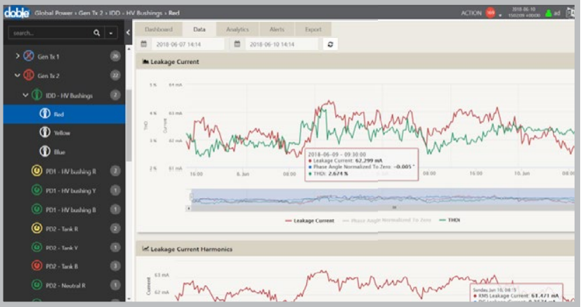
Figure 8: L&T’s Solution Component – Dashboard with graphing and charting

End User Interface – Reports
L&T’s solution will provide several graphical reports that show variety of information including both historical trending of various DGA tests but also allows comparisons of similar/families of assets.
Figure 9: L&T’s Solution Component – Comparison Reports

End User Interface – Alerts & Notifications

The SCMS platform provides intelligent alarm & event management features for both visualization as well as analysis.
Key salient features of alarms and event management module are as follows:
- Alarm & visualization in tabular format sorted by timestamp
- Alarm & event grouping by severity and/or source of alarm
- Dedicated alarm dashboard based on user preference to summarize alarms by category, source, severity etc.
- Alarm filtering, acknowledgement with complete audit trail and history
- Alarm grouping by type of alarms, and user defined criteria e.g. pending alarms, unacknowledged alarm beyond certain time etc.
- User configurable alarm settings
- Alarm trend analysis and root cause analysis based on associated data/event via drill-down/drill-up navigation views
- User role and AOR (Area of Responsibility) based alarm access
- System wide as well as substation/equipment wise threshold/settings updates for alarm/even generation
- Alarm and event history available in local database at each substation in the L&T Data Gateway accessible locally at the substation or direct access via SCMS user interface
Each time the user logs in to the SCMS portal (User Interface), the default dashboard view provides the summary of alarms, list of pending as well as active alarms depending on the role and the AOR of the user.
User can view system wide alarms summary as well as seamlessly switch between substations to view alarm details, history and summary pertaining to a particular substation.
User can be notified (based on user preferences and role configuration) via email, SMS based on pre-configured rules that can be set by the users as per their preference.

System Features & Services

Cybersecurity

The SCMS Solution is fully compliant with applicable cyber security standards prescribed in NIST (USA)’s “Framework for Improving Critical Infrastructure Cybersecurity V1.1 dated April 16, 2018”, NERC CIP and ISO/IEC27002 standards.

Following table summarizes key aspects (kindly note it’s not comprehensive list) of cyber security philosophy in L&T’s SCMS solution. The L&T Digital Solutions’ cyber security policy and procedures are details in “L&T Digital Solutions Cyber Security and Secure Development Process and Compliance” document which will be provided as part of project deliverable during implementation.

Topic | Requirement
Authentication | Passwords are encrypted during authentication process and clear text passwords are neither used during transmission or data at rest
Logging | All user actions, application and system component actions are logged in audit, event and error logs for post event analysis and these logs are never purged from the system
Network Services | All network services are secured using digital certificates. All network services are blocked by default until and unless required by the SCMS solution
Passwords | Password management module meets minimum requirements for NERC CIP-007-1 compliance as well as following additional provisions are implemented:  Password Requirements:  - Minimum 8 characters  - 1 lowercase letter  - 1 uppercase letter  - 1 number  - 1 special character  - Change every [configurable] period
Antivirus Software | Latest version of antivirus software (for non-Unix/Linux environments) are installed and set for automatic updates
Application Patches | Critical application patches are installed as soon as they are available and as required by customer’s Cyber Security policies.
Operating System Patches | Customer’s Cyber Security policies are enforced for patching of critical patches and based on the preferences automatic update functionality for the OS are enabled.
Security Template | Window Security Template is installed (on windows machines/servers) to automatically configure baseline security settings as per customer’s Cyber Security policies.

End Point Security

The endpoint protection is implemented on all hardware and software solution components of SCMS solution.

The central component of the SCMS solution protects networks and all the endpoints from threats using tools such as firewalls, anti-malware, device management, data loss prevention, etc.
Following is the summary of key aspects of endpoint security features. L&T Digital Solutions “L&T Digital Solutions Cyber Security and Secure Development Process and Compliance” document details the endpoint security requirements and implementation plan, which will be provided as part of project deliverable during implementation.
- Endpoint Detection: Discovery and report of new and unknown endpoints and associated vulnerabilities
- Anti-malware and data protection: Solution includes all core endpoint protection capabilities viz., DLP, firewalls and anti-malware software
- Reports: Endpoint security specific dashboards and reports are provided to monitor and control cyber security operations.
- Enterprise Security Integration: The SCMS solution integrates with customer’s security applications such as active directory, network monitoring as well as SIEM applications.
- The ICS infrastructure fully complies with the NIST guidelines for cyber security requirements for critical infrastructure.
Additionally, device physical security is ensured (in conjunction with customer’s cyber security policies) such as:
- Access is restricted to those that need (based on AOR and role) to maintain the covered devices and/or media.
- Restricted devices are clearly marked for authorized personnel only.
- Access to the devices is logged in the audit trail.

Application Security

The SCMS Solution is developed using secure coding best practices and complies with various industry standards. The Secure coding practice guidelines are documented in the “L&T Digital Solutions Secure Coding Practice Process and Guidelines” document which shall be provided as one of the deliverables during the project implementation.

Outline of the Application Security and secure coding practices is as follows.
- Secure Coding Training: Software Engineering Managers and Solution Managers ensure that programming staff developing the solution/applications complete secure development training
- Application Security Testing: Software Engineering Managers and Solution Managers ensure that solution and applications pass security assessment prior to release to for general availability (major releases) and every 1 years thereafter.
Application security assessments includes the following:
- Testing methodology and risk assessment criteria as defined by the policy document.
- Review of documented requirements and use cases.
- Credentialed and non-credentialed vulnerability scans conducted on a validation and verification lab environment that includes web, application and database servers.

- Code Review: Software Engineering Managers and Solution Managers ensure that code review is incorporated into each phase of the software development life cycle.
- Third-party Commercial Software Assessment: Software Engineering Managers and Solution Managers validate that third party open-source and/or commercial software meets security criteria prescribed by the “L&T Digital Solutions Third Party Open Source and Commercial Software Assessment and Usage Policy” document and tested prior to implementation in the SCMS solution.
- Continuously assess and remediate vulnerabilities: Application testing tools are used to,
- Automate daily vulnerability testing.
- Generate alerts and escalate the visibility of critical vulnerabilities within 48 hours.
- Compare prior scans to verify that vulnerabilities are addressed.
- Report on unmitigated vulnerabilities to department and senior management.
- Measure the delay in implementing patches.
The application security testing results will be provided during the implementation phase of the project.

Identity Access Management

The SCMS Identity and Access Management (IAM) module assures that the identity of an entity (user, process or system) is verified, before granting the correct level of access based on the protected resource, this assured identity, and other context information.
IAM components discussed include:

- Centralized Directory Services (integration with enterprise AD or LDAP services)
- Access Management Services (built-in or integrated with enterprise AD or LDAP)
- Identity Management Services
- Identity Federation Services (e.g. Single sign-on)
- Role-Based Access Control Services
- User Access Certification Services (secure access)
- Privileged User and Access Management
- Identity and Access Reporting Services (audit logging and reporting)

Authentication process of verifies the credentials of an entity (user, process, system) trying to access a protected resource in the SCMS. The SCMS authentication is performed in a secure, trustworthy, and manageable manner. The SCMS Authentication provides adaptive authentication based on the level of risk of the transaction.

The SCMS IAM also provides Single Sign-On (SSO) where user is authenticated once and the credentials for the session are trusted across different applications within a security domain.

Strong authentication is implemented in SCMS that requires the use of two or more of the three types of authentication factors. Functionalities such as a One Time Password can be configured and supported based on the customer’s cyber security and access management policies. The multi-factor (e.g., One Time Password (OTP)) is supposed as an option in the SCMS IAM.

Identity Access service provides features such as provisioning and deprovisioning management. Provisioning process is used to create (or import from AD or LDAP) accounts to allow users to access appropriate systems and resources in the SCMS. This streamlines account creation and provide a consistent framework for providing access to end users. Deprovisioning process ensures that a user account is disabled when the user no longer requires access due to users leaving an organization, transferring within an organization, a change in role, etc. Deprovisioning process also manages the termination or disabling of user accounts in SCMS.

Authorization and Access Management Authorization and access management forms a broad category of services that are provided by SCMS to ensure cyber security. While authorization determines the user’s right to access a certain resource, access management enforces that users’ access to a certain resource within SCMS is managed with respect to the user’s credentials and attributes associated with the identity.

The SCMS also logs all access from known as well as unknown users and proactively sends alerts and notifications to the administrators (or user with associated roles) regarding an attempted unauthorized access or use of the system. The password management policy is given in the section 3.1.4 above in this document.

Network Security

The SCMS maintains configuration of all network (including firewalls) assets and associated configuration in the central system as well as in each of the gateway devices in substations with approved and configured list of services, protocols, ports etc.

The security and network configuration are also available from the dashboard views where user with appropriate access rights can navigate to any device or group of devices from the user interface and manage/view network configuration and associated services for a selected node.

The security report includes the status of network nodes, security incidents, firewall logs etc. and alerts the users with appropriate role of the incident reports. The section 3.1.4 of this document provides summary of the cyber security policies and processes implemented in SCMS.

OT Security Monitoring

The SCMS provides detailed security audit and event logs in the central server as well as at each network node (firewall, switches and gateway devices). The central server stores the audit and event logs in to the dedicated SYSLOG server. These logs are associated with the unique ID of each of the asset under the purview of SCMS and hence logs and events can be associated and traced back to the source of the root cause in case an incident related to security occurs.

The SCMS thus automatically collects Indicators of Compromise (IOCs) to drive the threat intelligence which can also be integrated with the customer’s enterprise security monitoring system.

The SCMS continuously and automatically monitors the network services, devices and applications and flags the cyber security events as well as the environmental parameters such as humidity, temperature etc. to detect potential failures or vulnerabilities.

Change and Patch Management

L&T Digital Solutions Change Management process is designed to help control the life cycle of strategic, tactical, and operational changes to L&T solutions through standardized procedures. The goal of Change Management is to control risk and minimize disruption to SCMS solution and associated operational systems.

On the other hand, SCMS Solution over a period will need to be serviced with updates and patches during their lifetime. Typically, updates will provide new functionality or better performance, and patches will be released to fix software bugs. Especially in the case of security issues, patches are quickly deployed across the SCMS (Smart Monitoring) network to prevent possible exploitation.

As part of the patch management process solution/application patches and updates are propagated as application in all the SCMS solution components viz., network components, OS, Software’s & Components, Anti-Virus/Malware tools at the earliest possible schedule approved by the customer.
L&T Digital Solutions’ Change & Patch management policies streamline deployment of patches as well as change management process, this document will be delivered during project implementation.
The planned changes then go through the formal Change and Patch management process defined by the customer.
L&T will host a separate dedicated test environment (called staging environment) at L&T office in Qatar or at KM-1 facilities at customer site. It will be used to test the patches and application/OS level upgrades to ensure integrity of the solution and business continuity.
L&T expects that each change or patch is duly approved, authorized and scheduled by the customer in timely manner. All changes on the affected systems must go through change management process.
A brief summary of Change management process as implemented by L&T Digital Solutions is given below. L&T will submit change proposal with a high-level description of a proposed changes and includes implementation schedule. These proposals are created by the solution and project management process at L&T and are passed to the change management process of customer. The objective of the formal change proposal is to ensure minimal disruption to the SCMS (Smart Monitoring) operation and business activities.

Create/Log a Request for change (RFC)

A Request for Change is created by the L&T project team& depending on the type of change, an RFC record will contain varying information necessary to make decisions for authorization and implementation of the change, including, identifying information, a description, configuration item incurring the change, a reason for the change, type of change, timeframe, costs, rollback plan and (if required by customer) the business justification.

Review RFC

Each Request for Change (RFC) will be reviewed and prioritized by the change management lead/team at customer. These requests can be rejected and returned to the L&T as notification or in request of more detail. These unapproved changes are be monitored and closed as needed.

Evaluate RFC

Evaluation of the RFC to assess the impact, risk and benefits to SCMS operational system by customer is critical in order to avoid unnecessary disruption to business operations. For certain types of changes, such as major changes, a formal change evaluation takes place by the change evaluation process and is documented in a Change Evaluation Report by L&T. Typically a Change Advisory Board (CAB) which includes L&T (designated) personnel and customer personnel evaluates the changes.

Approve and Authorize the Change

L&T requires customer’s authorization prior to implementation and each change requires authorization from the customer depending on type and scope of change (strategic, tactical, operational).

RFC - Implement the Change

Once customer approves the RFC, a change request or the change record is handed over to the release and deployment process for coordination and collaboration with the L&T’s technical solution delivery team for building, testing and deploying the change. Each change has remediation plans in the case of an implementation failure and the changes need to be rolled back. The L&T project management team schedules each change based on the suggested implementation requirements and the management of operations/business risk. The L&T project management using a Forward Schedule of Changes (FSC) or Change Schedule communicates to all stakeholders at customer upcoming changes that may impact the operation. The FSC along with projected service outages (PSO) or expected deviations in SCMS solution availability, will be taken into consideration when coordinating change implementation. L&T project management team is be responsible for implementation and coordination of training needs (if required due to the changes).

Training

User Interviews
L&T recommends the initial step for successful training requires understanding the audiences’ technical, functional and learning expectations. L&T will conduct these interviews to identify skills, gaps, and adjust training plan content to accommodate for identified items.

Training with full compliance

In compliance with Kahramaa’s training specifications, L&T will provide user manual and system maintenance documentation, and three (3) days of Theoretical Training and three (3) days of Practical Training at a location acceptable to Kahramaa staff.

L&T recommends the following approach to effective knowledge transfer for operation and support of the system. This training will include in-person instruction, written training documentation, and hands-on operation of the systems:

Theoretical Training

Day-1 | - Introduction Session  - Needs and Skills Analysis  - Individual Skill Assessment  - Skills Gap Matrix  - Kahramaa Staff expectations & learning objectives  - Training Plan Adjustment as required | 4 Hours
 | - Telecom Basics | 2 Hours
 | - System Architecture | 2 Hours
Day 2 | - Transformer Monitoring System Features  - Transformer Oil parameter monitoring (Qualitative & Quantitative)  - Temperatures  - Humidity  - Moisture  - Pressure  - Cooling Efficiency  - Electric current  - Electric voltage  - Partial discharge  - Alarms & Events | 2 Hours
 | - Communications interface connections | 2 Hours
 | - Operation system data interpretation  - Power Transformer/ Reactor Partial discharge measurements  - OLTC Monitoring  - Dissolved gases  - Winding Hot Spot  - Electric Voltage  - Electric Current  - Ambient Oil & Winding Temperature | 4 Hours
Day 3 | - System Diagnostic Tools  - Duval triangle  - Duval Pentagon  - IEC method  - IEEE Conditions  - Cigré risk assessment  - Utility benchmark comparison | 4 Hours
 | - Theoretical Hands-on training | 4 Hours

Practical Training

 | Hands-on Practical Training
Day 4 | - System Features  - Transformer Oil parameter monitoring (Qualitative & Quantitative)  - Temperatures, ambient, top-oil, transformer hot-spot  - Humidity  - Moisture  - Pressure  - Cooling Efficiency  - Electric current  - Electric voltage  - Frequency  - Load Factor  - Active, reactive & apparent power  - Partial discharge  - Protective Device status  - Tap changer monitoring  - Switchgear monitoring  - Bushing Monitoring  - Variances between vendor models  - Alarms & Events  - Set point parameters  - Parameter change authorizations | 2 Hours
 | - Error Handling | 2 Hours
 | - System Maintenance  - Alarm lists  - Event history  - Access authorization  - Access history  - Data management, migration, restoration | 2 Hours
 | - Communications interface connections | 2 Hours
- Operation system data interpretation
  - Power Transformer/ Reactor Partial discharge measurements
  - OLTC Monitoring
  - Dissolved gases
  - Winding Hot Spot
  - Electric Voltage
  - Electric Current
  - Ambient Oil & Winding Temperature
Day 5 | - Technical trouble shooting | 2 Hours
 | - System Administration | 3 Hours
 | - System Diagnostic Tools  - Duval triangle  - Duval Pentagon  - IEC method  - IEEE Conditions  - Cigré risk assessment  - Utility benchmark comparison | 3 Hours
Day 6 | - System Operations  - Alarms: add, delete, modify  - Systems: add, delete, modify  - Pending Alarms  - Insulation aging rate  - Insulation cumulative age  - Recording dissolved gas parameters  - Configuring threshold parameters  - Sampling schedule configuration  - Trouble shooting  - System backup, restore, recovery | 4 Hours
 | - Reports  - Creation  - Modification  - Deletion  - Distribution | 4 Hours

Product Warranty Support

Overview
Our technical proposal is fully compliant with the 3-year warranty support requirement as stated in the RFP.
The L&T PT&D Digital Solutions delivery of service under warranty provides troubleshooting assistance for product conformance to the project in context. L&T will provide priority assistance, 24x7x365, troubleshooting and guidance with set up, configuration, interoperability or additional advance technical troubleshooting, for the 3 years duration from the date of project go-live. L&T also will provide warranty support for the same time period for all third-party solution components (hardware and software) delivered under this project.

The following table provides summary of warranty support:

Solution Component | Warranty Duration | Hardware Replacement | 24X7X365 Technical Support | Software Patch Releases
SCMS | 3 years from the date of production go-live | N/A | Yes | OS Patches as soon as made available and certified by L&T and Customer  Software Patches – 24 hours for critical defects  Regular patches – Every 6 months
Servers and Workstations | 3 years from the date of production go-live (back-to-back with the OEM) | 3 business days | Only business hours support (weekdays 8 AM to 6 PM local time) | N/A
Networking Equipment | 3 years from the date of production go-live (back-to-back with the OEM) | 3 business days | Only business hours support (weekdays 8 AM to 6 PM local time) | N/A
L&T Substation Data Gateway | 3 years from the date of production go-live | 24 hours | Yes | OS Patches as soon as made available and certified by L&T and Customer  Software Patches – 24 hours for critical defects  Regular patches – Every 6 months

